Term Set Webpart Documentation

1. TermSet.tsx

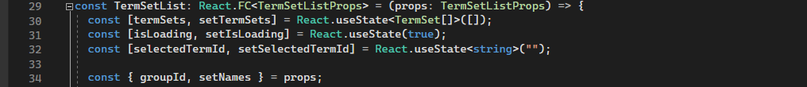  
Set up states needed to track term set and loading,

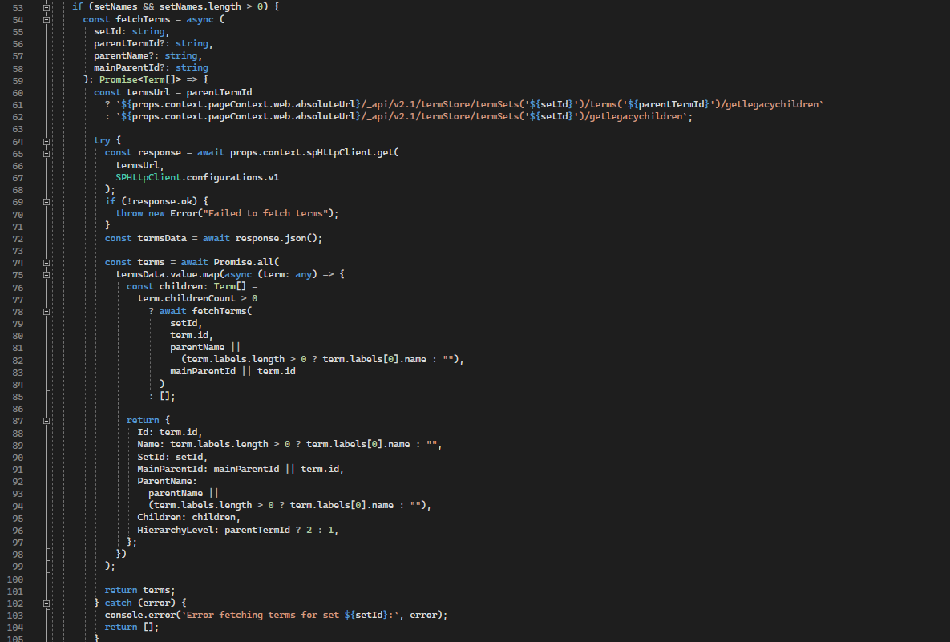  
  
The above method fetches the terms from the Termstore. It receives the setId and fetches all the terms or groups under it.

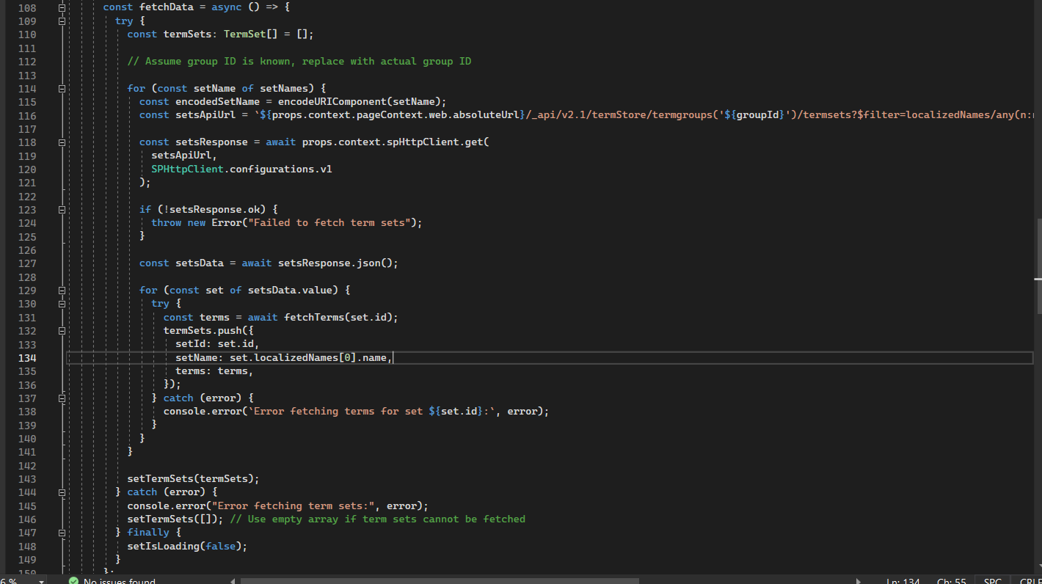  
  
This method fetches the list of term groups under sets. After that, it also uses the previous function to fetch child terms and sub-children terms.   
  
The above methods run inside the use effect and is responsible for setting up the states.

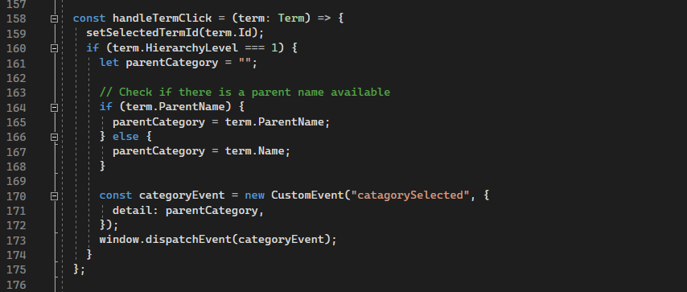

This is the method that is going to be called when a Knowledge base is selected. It fires an event called “catagorySelected” and also send the selected Knowledge base along with the event. That event is listened by the PagesDisplay webpart and render the pages accordingly.

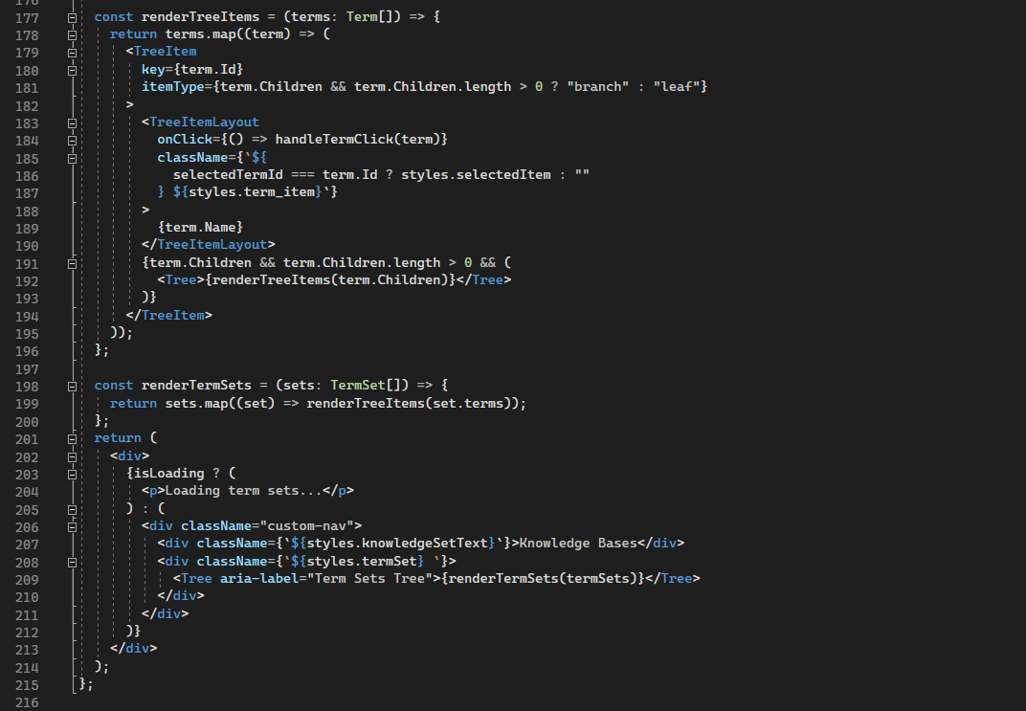  
  
The renderTermSet will render the terms along with their sub-items in tree format. It will call the renderTreeItems recursively and that will do the rending accordingly.

1. TermSetWebpart.ts

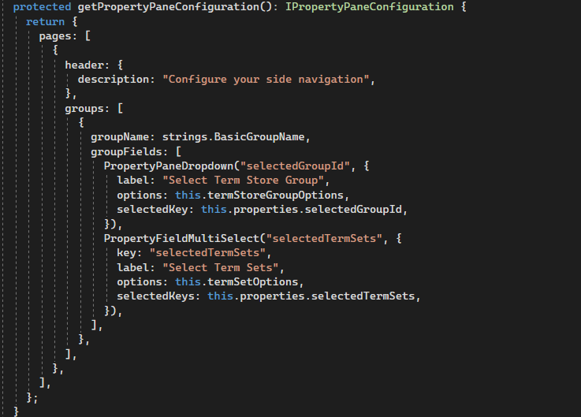

The wanted TermStore group and TermSet options will be selected by using the property pane.

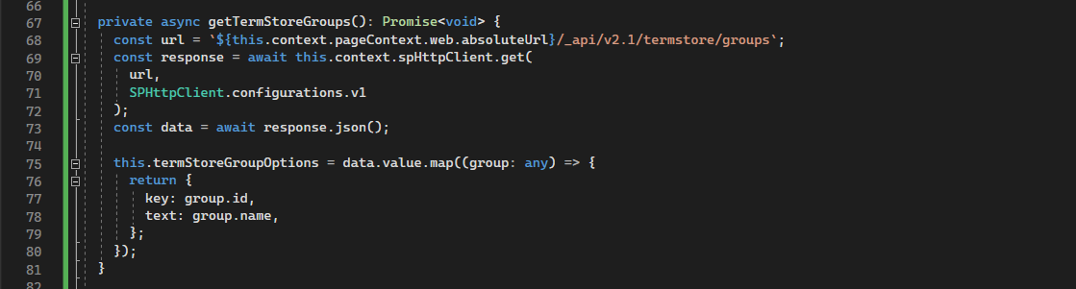  
  
The possible term store groups will be fetched here and will be stored in the variable “termStoreGroupOptions”.

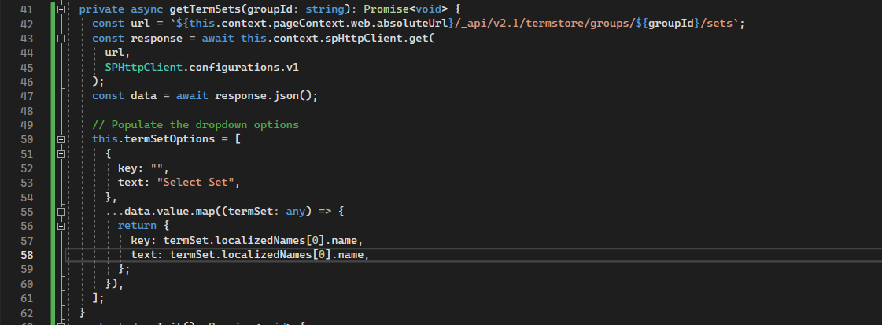  
For the selected term group the termsets under it will be fetched using this method.  
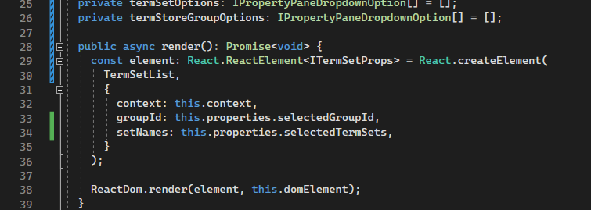  
  
Finally, the selected group and set names will be passed to TermSet.tsx file as props.